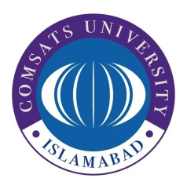
COMSATS University, Islamabad
Sahiwal campus
Works Department
COMSATS Road, Off G.T.Road, Sahiwal
Tel: 040-4305004 Web: www.cuisahiwal.edu.pk

Notice Inviting Expression of Interest (EOI)
(No. COMSATS/SWL/WD/968/21)

- COMSATS University Islamabad, Sahiwal campus, a public sector university under Ministry of Science and Technology invites consultancy services for the designing of Academic block and cafeteria (Architectural & structural drawings, BoQ, Engineer’s cost estimate and Tender Documents). Method of selection for the work will be Quality and Cost Based Selection.
- Expression of Interest documents, which are containing name and address of procuring agency, appropriate description of assignment providing scope of the intellectual and professional services required, deadline and place of the submission of the expression of interest and evaluation criteria are available for the interested bidders at Works Department, CUI, Sahiwal campus. Price of the EOI documents is Rs. 1000.
- The expression of interest, prepared in accordance with the instructions in the EOI documents, must reach at Works Department, CUI Sahiwal campus on or before 1030 hours on Tuesday, November 09, 2021. The expression will be opened at 1100 hours on the same day in the presence of consultant’s representative who choose to attend at the same address. This advertisement is also available on PPRA website at www.ppra.org.pk and campus website at www.cuisahiwal.edu.pk.

Ali Shair
Incharge Works / Assistant Engineer
COMSATS University Islamabad,
Sahiwal campus
Ph: 040-4305004

